General Information: Georgia is situated on crossroads of Europe and Asia where east meets west, between the Black and Caspian Sea, to the south of the Great Caucasus Range. It shares borders with the Russian Federation to the north, Turkey and Armenia in the south and Azerbaijan in the east. Georgia has a population of 4.6 million and occupies an area of 69,7 thousand sq/km, which is distinguished by diverse climates and geography.
Climate: Climatic zones range from the heat of the subtropics to the eternal snow peaks of the mountains, from a moderately humid Mediterranean-type climate to a dry continental climate. In the lowlands, the summers are hot and winters are moderate. The average summer temperatures range from 250C to 280C, average winter temperatures range from 20C to 40C.
Time Zone: GMT + 4:00
Population: 4.3 million, Georgians – 70%, Armenians – 8%, Azeris – 6%, Russians – 5%, Greeks – 2%.
Capital: Tbilisi, pop. 1.2 million
Main Towns: Kutaisi, Rustavi, Batumi, Gori, Telavi, Mskheta
Language: The official language is Georgian, which has its own alphabet. All signs and makers along the main road are written in both Georgian and Latin letters. Most people also speak Russian
Religion: Georgian Orthodox (main), Catholic, Muslim, Armenian Gregorian, Jewish
Travel documents: To travel to Georgia the residents of the European Union, United States, Canada, Switzerland, United Arab Emirates, Antigua and Barbuda, Argentine Republic, Barbados, Belize, Bosnia and Herzegovina, Commonwealth of Australia, Dominican Republic, Commonwealth of the Bahamas, Federative Republic of Brazil, Hellenic Republic, Holy See, Iceland, Japan, Kingdom of Bahrain, Kingdom of Norway, Kingdom of Saudi Arabia, Kingdom of Thailand, Kyrgyz Republic, Lebanese Republic, Malaysia, Montenegro, Nation of Brunei, New Zealand ,Principality of Liechtenstein, Principality of Andorra, Principality of Monaco, Republic of Korea, Republic of Albania, Republic of Armenia, Republic of Azerbaijan, Republic of Belarus, Republic of Botswana ,Republic of Colombia, Republic of Costa Rica ,Republic of Ecuador, Republic of El Salvador, Republic of Honduras, Republic of Kazakhstan, Republic of Mauritius, Republic of Moldova, Republic of Panama, Republic of San Marino, Republic of Serbia, Republic of Seychelles, Republic of Singapore, Republic of South Africa, Republic of Tajikistan, Republic of Turkey, Republic of Uzbekistan, Russian Federation, Saint Vincent and the Grenadines , State of Israel, State of Kuwait, State of Qatar, Sultanate of Oman, Turkmenistan, Ukraine, United Mexican States need a passport valid for at least six months and can stay in the country without a visa for up to 90 days. Visitors from other countries may need to apply for a visa before traveling to Georgia. In some cases visas might be issued while crossing land boarders or upon arrival at Tbilisi or Batumi international airports. For the detailed information, visit ministry of foreign affairs official website: http://www.mfa.gov.ge/
Travel to Georgia/Available airlines: Austrian Airlines, Lufthansa, Czech Airlines, Air Baltic, Turkish Airlines, and BMI operate regular flights to Georgia. It's also possible to reach the country by train from Armenia and Azerbaijan; by boat via Batumi Port or by crossing land borders with Turkey, Armenia and Azerbaijan.
Traveling within Georgia: It's possible to travel in the regions of the country by public transport: buses, minibuses and trains are all inexpensive and relatively easy to use. There are a few scheduled minibuses that provide transportation to almost all the large and middle size villages. However to reach some mountainous areas, such as Tusheti, Svaneti, Racha –Lechkhumi, 4WD vehicles are recommended.
Transport on Chavchavadze avenue:
Bus #: 88, 140, 9, 59, 34
For more detailed information or for planning your trip please visit: http://transit.ttc.com.ge/?page=schedule#/
Airport: 20 km from Tbilisi Centre (30 GEL – by taxi, 0.5 GEL – by bus)
Currency: Lari (GEL), 1 USD = 2.45 GEL, 1 EURO = 2.7GEL
Electricity/ Power Supply: 220 V, 50 Hz. two round-pin plugs are used
Communication: When calling Georgia, the country code is 995; area code for Tbilisi is 32. Mobile telephone: GSM 900 and 1800 network. Coverage extends throughout most of the country, with the notable exception of some high mountain regions (please visit www.geocell.com.ge; www.magtigsm.com; www.beeline.ge for detailed information about available mobile operators).
Useful telephone numbers: Emergency number 112; Information service 11809.
When travel in Georgia, you can bring your own GSM cell phone and just purchase the Sim card in Geocell, Magti GSM or Beeline offices.
Water: Tap water is safe to drink in most areas. The spring water in the mountains is even safer. Bottled carbonated mineral water “Borjomi”, “Nabeglavi”, “Likani” or still water is a good alternative to tap water, and is widely available in cities and small towns.
Working Hours: Public Institutions-9:00 AM – 6:00 PM; Business Organizations-9:00 AM or 9:30AM – 6:00 PM or 7:00 PM; Shops and Supermarkets-10 AM – 7:00 PM or 8:00 PM; Subway -6:00 AM – 12:00 PM; Public Transportation (Bus, Minibus) - 6:00 AM – 11:00 PM.
Banks: Bank opening hours 10:00 – 16:30 (10:00 – 14:00 on Saturday); VISA, MasterCard and American Express are used. You can get cash in ATM in every district of Tbilisi.
Here is detailed information about ATM in Tbilisi, follow the links:
TBC Bank ATM: http://tbcbank.com.ge/en/
Bank of Georgia ATM: http://bankofgeorgia.ge/en/information/locations/branches-and-atms
Bank Republic ATM: http://www.republic.ge/index.php?lang_id=ENG&sec_id=173
Health & Safety: Tbilisi is a safe city and violent crime is very unusual. Normal precautions should be taken, including keeping track of your wallet or other valuables on crowded buses and trains.

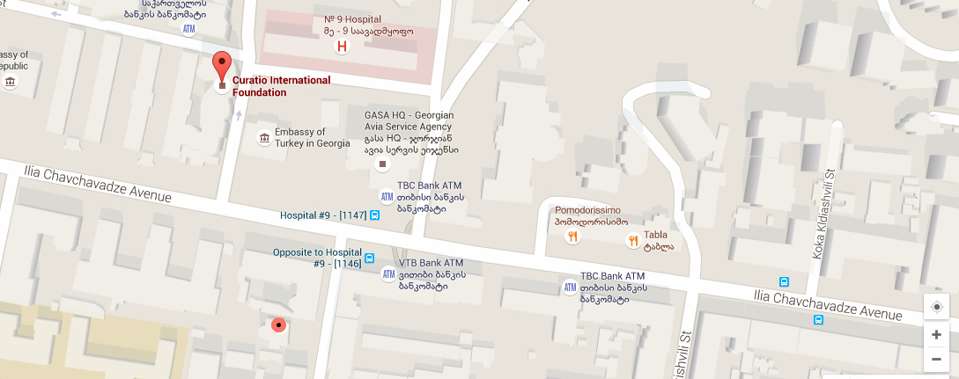
Cost of Living in Tbilisi:
Apartment’s rental cost (monthly, daily) average daily cost -$60; average monthly $300-700 depending on the location and apartment size)
For the detailed information, please visit the link: http://www.rentals.ge/; http://place.ge/ge; http://tbilisihotels.bookonline2save.com/
Hostels are also available in Tbilisi the private room average price is $ 35 and the dorm price is $15 (Possible hostels to stay “Oribeli” https://www.facebook.com/hosteloribeli/info ; “Darchee” https://www.facebook.com/DarcheeHostel/info and others)
Guest house rental average cost per person per night is $18.
Hotel rental average cost per person per night is $80.
For the detailed information, please see the link: http://www.guide-georgia.ge
CIF Contact Details:
Address:
Office 1: 37d, Chavchavadze Avenue, P.O. Box 56, 0179, Tbilisi, Georgia
Office 2: 3 Kavsadze Str., Office No 5, P.O. Box 56, 0179, Tbilisi, Georgia
Tel: (995 32) 2 251344; 2 253104; 2 253196
Fax: (995 32) 2 99 55 40
E-mail: internship@curatio.com; m.uchaneishvili@curatio.com
Detailed map:

For the medical emergency visit Medi Club: http://biz.aris.ge/en/company/4074/
For detailed information regarding recommended vaccinations see annex 1 below.
Annex 1: Recommended vaccinations
Before visiting Georgia, you may need to get the following vaccinations and medications for vaccine-preventable diseases and other diseases you might be at risk for at your destination:(Note: Your doctor or health-care provider will determine what you will need, depending on factors such as your health and immunization history, areas of the country you will be visiting, and planned activities.)
To have the most benefit, see a health-care provider at least 4–6 weeks before your trip to allow time for your vaccines to take effect and to start taking medicine to prevent malaria, if you need it.
Even if you have less than 4 weeks before you leave, you should still see a health-care provider for needed vaccines, anti-malaria drugs and other medications and information about how to protect yourself from illness and injury while traveling.
CDC recommends that you see a health-care provider who specializes in Travel Medicine. Find a travel medicine clinic near you. If you have a medical condition, you should also share your travel plans with any doctors you are currently seeing for other medical reasons.
If your travel plans will take you to more than one country during a single trip, be sure to let your health-care provider know so that you can receive the appropriate vaccinations and information for all of your destinations. Long-term travelers, such as those who plan to work or study abroad, may also need additional vaccinations as required by their employer or school.
Be sure your routine vaccinations are up-to-date. Check the links below to see which vaccinations adults and children should get.
Routine vaccines, as they are often called, such as for influenza, chickenpox (or varicella), polio, measles/mumps/rubella (MMR), and diphtheria/pertussis/tetanus (DPT) are given at all stages of life; see the childhood and adolescent immunization schedule and routine adult immunization schedule.
Routine vaccines are recommended even if you do not travel. Although childhood diseases, such as measles, rarely occur in the United States, they are still common in many parts of the world. A traveler who is not vaccinated would be at risk for infection.

vaccination or Disease | Recommendations or Requirements for Vaccine-Preventable Diseases
Routine | Recommended if you are not up-to-date with routine shots, such as measles/mumps/rubella (MMR) vaccine, diphtheria/pertussis/tetanus (DPT) vaccine, poliovirus vaccine, etc.
Hepatitis A or immune globulin (IG) | Recommended for all unvaccinated people traveling to or working in countries with an intermediate or high level of hepatitis A virus infection (see map) where exposure might occur through food or water. Cases of travel-related hepatitis A can also occur in travelers to developing countries with "standard" tourist itineraries, accommodations, and food consumption behaviors.
Hepatitis B | Recommended for all unvaccinated persons traveling to or working in countries with intermediate to high levels of endemic HBV transmission (see map), especially those who might be exposed to blood or body fluids, have sexual contact with the local population, or be exposed through medical treatment (e.g., for an accident).
Polio | Recommended for adult travelers who have received a primary series with either inactivated poliovirus vaccine (IPV) or oral polio vaccine (OPV). They should receive another dose of IPV before departure. For adults, available data do not indicate the need for more than a single lifetime booster dose with IPV.
Rabies | Recommended for travelers spending a lot of time outdoors, especially in rural areas, involved in activities such as bicycling, camping, or hiking. Also recommended for travelers with significant occupational risks (such as veterinarians), for long-term travelers and expatriates living in areas with a significant risk of exposure, and for travelers involved in any activities that might bring them into direct contact with bats, carnivores, and other mammals. Children are considered at higher risk because they tend to play with animals, may receive more severe bites, or may not report bites.

